**Women Empowerment Issues**

1. **Enrollment:** In this form You cannot submit the data without filling the state, District, Block, Village, Women name, Mob no., Father Name Itshould beCompulsory.
2. **Enrollment:** Whether Part of any SHG If you select yes other 3 indicator should be fill.

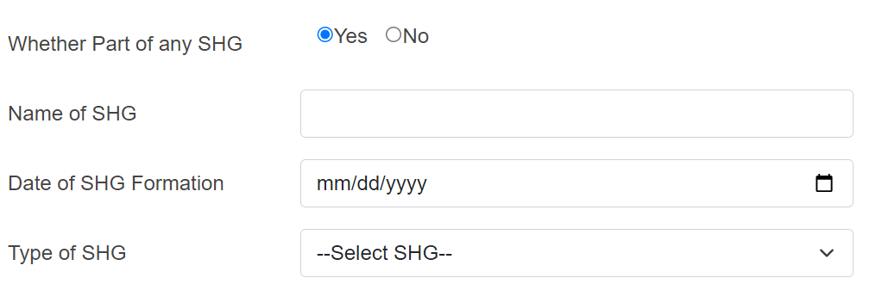

1. **Enrollment:** In this indicator when you select pwd is yes then without specify you can not submit the form.

1. **Enrollment**: Theme code should be disabled Automatically Filled. There is no need of Drop-down menu.



1. **Enrollment**: After Aadhaar Card if you select yes in willing to provide Aadhaar card indicator then Adhaar Number should be compulsory To Fill.

1. **Enrollment**: In this indicator Add the drop-down Values. Which is similar to Govt of India.

1. **EDP Training:** Remove Date Validation. When we select any training date then data should be submitted**.**
2. **EDP Training**: If we select yes, In Life Skills Training then only financial training should be compulsory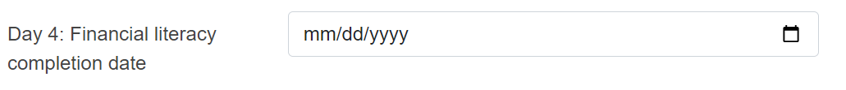
3. **EDP Training**: If we select yes, In Enterprise developed Training then only EDP Training Completion date should be compulsory.

